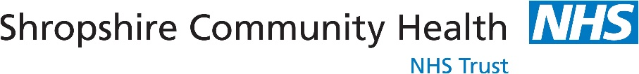

Public Health Nursing Service
Coral House
11 Longbow Close
Shrewsbury
SY1 3GZ

Telephone: 0333 358 3654

Academic year 2023-2024

Height and weight checks for children in Reception and Year 6

Every year in England, school children in reception and year 6 have their height and weight checked at school as part of the National Child Measurement Programme. Height and weight measurements are used to calculate weight status. We collect this information to build a picture of how children are growing to help plan better health and leisure services for families. In most areas, parents receive their child’s measurement data as this can be useful information about their child’s growth and provides an opportunity to offer support to parents where required. Your child’s class will take part in this year’s programme.

The checks are carried out by registered school nurses or trained health care support workers. Children are measured fully clothed, except for their coats and shoes, in a private space away from other pupils. The programme will be delivered in a safe way, in line with the school and local authority’s safety control measures and national guidance for schools and healthcare.

Maintaining the well-being of children in the NCMP
The wellbeing of children and families is very important. Measurements are conducted in a sensitive way, in private and away from other children. Individual results are not shared with your child or their school. The weight and height information is shared only with you via a parent feedback letter and/or telephone call. It is your choice to share or not share the information with your child.

The emotional impact of the NCMP has been researched and studies show that body image, self-esteem, weight-related teasing and restrictive eating behaviours do not change as a result of being measured or receiving feedback. If you are concerned about your child’s growth, weight, body image or eating patterns, seek further support from a school nurse or General Practitioner.

The information we collect and what it is used for is listed below:

- your child’s date of measurement, sex and date of birth are used to calculate your child’s weight category
- your child’s name, date of birth and NHS Number are used to link your child’s measurements in Reception and Year 6. Other data sets held by NHS England and Department of Health and Social Care, may also be linked to allow the addition of information from health and education records, where lawful to do so, to understand how and why the weight of children is changing, and how this affects children’s health and education and how the care children receive can be improved. This includes your child’s health data relating to:
  - their birth, hospital care (including time in hospital and out-patient appointments and diagnosis of medical conditions)
  - mental health
  - social care
  - primary care - includes all healthcare outside of hospital such as GP and dental appointments,
  - public health - including data relating to preventing ill health such as immunisation records
  - records for when and the reason why people pass away
  - medical conditions such as cancer, diabetes
  - health, lifestyle and wellbeing surveys that your child has participated in
- your child’s ethnicity and address are used to help understand some of the reasons for the difference and changes in child weight across England.
- your address is required to send you your child’s feedback letter. This will include your child’s measurements together with information about healthy eating, being active and related activities available in your area.
- your telephone number is required as we may contact you to discuss your child’s feedback and offer you further support following your child’s height and weight measurement.

All the data collected is also used for improving health, care and services through research and planning.

All this information is treated confidentially and held securely. No individual measurements will be given to school staff or other children.

How the data is used

The information collected from all schools in the area will be gathered together and held securely by Shropshire Community Health NHS Trust. We will store your child’s information as part of their local child health record on the NHS’s child health information database.

All the information collected about your child will be sent by us to NHS England. NHS England is responsible for collecting data and information about health and care so that this can be used to monitor and improve the care provided to people across England.

The information collected about your child will also be shared by NHS England with the Office for Health Improvement and Disparities (OHID) which is part of the Department of Health and Social Care (DHSC) but in a de-personalised form only. This means OHID will not be able to identify your child. OHID focuses on improving the nation's health so that everyone can expect to live more of life in good health, and on levelling up health disparities to break the link between background and prospects for a healthy life.

Both NHS England and the Office for Health Improvement and Disparities (DHSC) will use the information from the National Child Measurement Programme to better understand numbers and trends in child weight and body mass index (BMI). This helps with the planning of services to support healthy lifestyles in your area. No information will ever be published by NHS England or the Office for Health Improvement and Disparities (DHSC) that identifies your child. NHS England use the data to produce National Child Measurement Programme statistics reports showing trends at national and local community level.

De-personalised information from the National Child Measurement Programme may also be shared by NHS England with other organisations, such as universities. This is to help improve health, care and services through research and planning. This information cannot be used to identify your child, and NHS England only ever shares information for research through formal assurance and approvals processes, seeking advice from experts as necessary.

How your child’s data is collected and processed as part of the National Child Measurement Programme (NCMP)

Local authorities have a legal duty to collect the NCMP data. They do this by following guidance from the Office for Health Improvement and Disparities part of the Department of Health and Social Care (DHSC). Local authorities are responsible for making decisions on how the data is collected and for making sure it is protected. Local NCMP service providers are contracted to carry this out; this might be through the school nursing team working in schools or a local healthcare provider. The team collecting the data enter it into the NCMP IT system, which is provided by NHS England. The data may also be entered into a local child health information system. Your local authority is responsible for sending the data to NHS England. NHS England and the Office for Health Improvement and Disparities are jointly responsible for the data held at a national level. Your local authority is responsible for the data held locally.

The diagram below displays what happens to your child’s data as part of the NCMP.

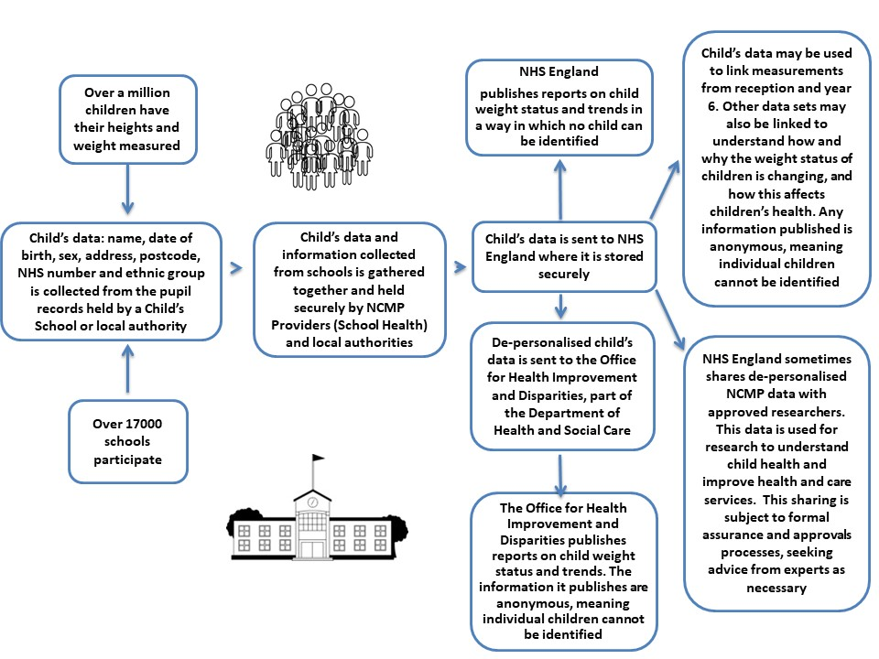

Further information

Further information about the National Child Measurement Programme can be found at https://www.nhs.uk/live-well/healthy-weight/national-child-measurement-programme

Information and fun ideas to help your kids stay healthy can be found at
https://www.nhs.uk/healthier-families/

Another way to help maintain a balanced diet and physical activity for your family is the NHS Healthy Steps email programme. Sign up for the 8-week Healthy Steps emails and you will be sent lots of low-cost easy tips, fun games, healthy swaps and tasty recipes on a budget.

Scan the QR code or visit healthysteps.uk to sign up.
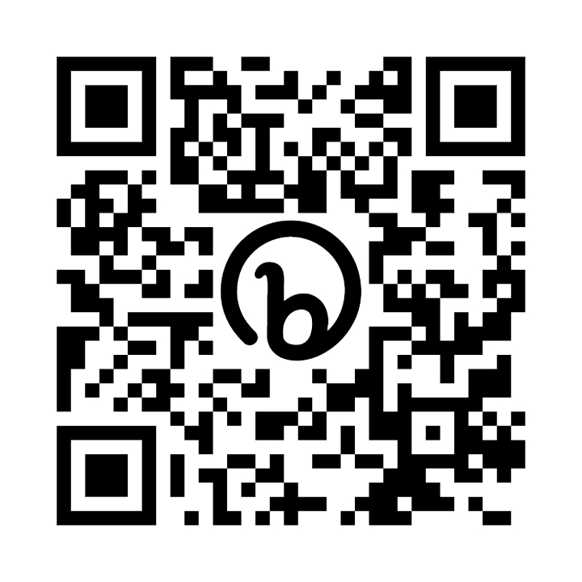

Information about how NHS England and Office for Health Improvement and Disparities collect and use information can be found at https://digital.nhs.uk/about-nhs-digital/our-work/keeping-patient-data-safe/how-we-look-after-your-health-and-care-information and https://www.gov.uk/government/organisations/department-of-health-and-social-care/about/personal-information-charter

Information about the organisations NHS England has shared information from the National Child Measurement Programme can be found at https://digital.nhs.uk/services/national-child-measurement-programme

Withdrawing your child from the National Child Measurement Programme

If you are happy for your child to be measured, you do not need to do anything, following this, a results letter will be sent to you in the post.

If you do not want your child’s height and weight to be measured please fill in the form at the end of this letter and return to the school office.

If your child has a medical condition that affects their height or weight please let the school office know before our visit.

Children will not be made to take part on the day if they do not want to.

Yours faithfully,

Public Health Nursing Service

NATIONAL CHILDHOOD MEASUREMENT PROGRAMME OPT OUT FORM.
Academic Year 2023-2024

NCMP Height and Weight Programme is an OPT OUT service, please only fill in this form if you DO NOT WANT your child to be weighed and measured, and return to the school office.

Thank You,
Public Health Nursing Service.

Child’s Full Name

Child’s Date Of Birth

Child’s NHS Number (if known)

Child’s School

Parent / Carer Name

Parent / Carer Signature

